Intro to Machine Learning Pre-Workshop Exercises

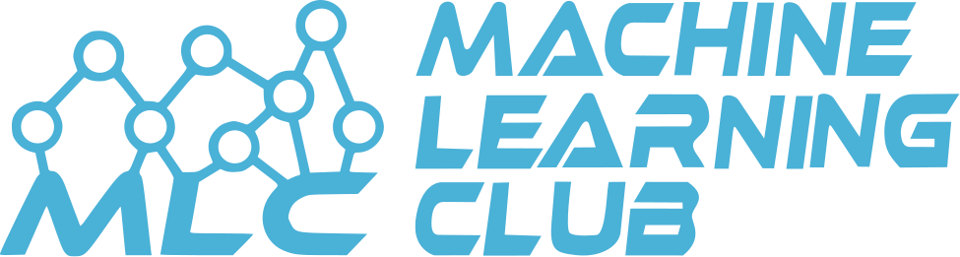

# What is Machine Learning?

# Which Line is the Best Fit?

1. Black
2. Gold
3. Blue

*What type of line is the best fit?*

*Why is it the best fit?*

# Which Line is the Best Fit?

1. Black
2. Gold
3. Green

*What type of line is the best fit?*

*Why is it the best fit?*